Report Release Date | 10th May 2026
Type of Audit | Web Application Testing
Type of Audit Report | Initial Audit Report
Period | 9th May 2026 – 10th May 2026
Client | GinandJuiceshop
Auditor | Hrushikesh Sanjay Nehete

Document Control
Document Preparation
Document Title
Document ID
Document Version
Prepared by | Hrushikesh Sanjay Nehete
Reviewed by
Approved by
Released by
Release Date | 10th May 2026

Document Change History
Version | Date | Remarks / Reason of change
1.0 |  | Initial Report by Auditor

Document Distribution List
Name | Organization | Designation | Email Id
Hrushikesh | ASD |  | Hrushikeshnehete1@gmail.com

Table of Contents
Contents
Document Control…………………………………………………………………………………………………………………………………………..2
Table of Contents……………………………………………………………………………………………………………………………………………..3
Company Profile………………………………………………………………………………………………………………………………………………..4
Imperium Solutions Profile…………………………………………………………………………………………………………………………….4
Targeted Audience…………………………………………………………………………………………………………………………………………….4
Audit Objective…………………………………………………………………………………………………………………………………………………..4
Audit Scope…………………………………………………………………………………………………………………………………………………………5
Engagement Scope……………………………………………………………………………………………………………………………………………5
Details of the Auditing team………………………………………………………………………………………………………………………….6
Methodology…………………………………………………………………………………………………………………………………………………….6
Tools/ Software used………………………………………………………………………………………………………………………………………8
Risk Summary……………………………………………………………………………………………………………………………………………………..8
Management Summary………………………………………………………………………………………………………………………………….10
Port Scan Details…………………………………………………………………………………………………………………………………………….12
Vulnerability Details………………………………………………………………………………………………………………………………………24
Detailed Report ……………………………………………………………………………………………………………………………………………….24
- SQL Injection Vulnerability in Search Parameter………………………………………………………………...25
- SQL Injection – Boolean-Based Blind SQL Injection……………………………………………………………..26
- Multiple Active Session Vulnerability……………………………………………………………………………….29
- Credentials transmitted to server in plain text……………………………………………………………………32
- Default credentials have been used for authentication………………………………………………………..33
- Version disclosure of JavaScript library (AngularJS v1.7.7)………………………………………………….35
- Missing Content Security Policy (CSP) header…………………………………………………………………….37
- Missing Referrer-Policy HTTP response header………………………………………………………………….39
- Missing Referrer-Policy HTTP response header………………………………………………………………….40
- Improper or missing input validation on user-supplied data……………………………………………….42
- XML version disclosure……………………………………………………………………………………………………...45

Imperium Solutions Profile
Imperium Solutions is a Cert-IN empanelled, ISO 9001 and ISO27001 certified organization, focused on Information Security and Data Privacy domains. Established in June 2008, we aim to partner with our clients to build and implement appropriate Information Security and Data Privacy Controls.
Imperium Solutions professionals have rich domain expertise across a cross section of industry verticals and the multi-dimensional skills to meet the ever-changing business needs of our clients.
Imperium Solution’s unique blend of customer focus and consistency in delivering services of the highest quality provides a competitive edge to our clients.
Our portfolios of solutions help our clients achieve their business objectives while maintaining the security and privacy of their data.

Targeted Audience
Citing the identified risks and vulnerabilities as mentioned in the report, it should be considered as Strictly Confidential and accessible only to the Top Management, IT Manager, Software Development Team, Software Testing Team and senior staff members responsible for taking action.

Audit Objective
The objective of this vulnerability assessment and penetration testing exercise is to
1 Identify the vulnerabilities existing in the network Database Server within the scope of the vulnerability assessment and penetration testing exercise.
2 Determine whether the vulnerabilities can be exploited and information gathered from the same.
3 Recommend solutions to plug these vulnerabilities.

Audit Scope
The following Database Server are in the scope of the VAPT exercise.
Sr. No. | IP Address | Make | Model
1
2
3

Engagement Scope
S.  No | Asset Description | Criticality of Asset | Internal IP  Address | URL | Public IP  Address | Location | Hash Value (in case of applications) | Version  (in Case of applications) | Other details such as make and model in case of network devices or security devices.
1. | Database Server | - | As per table above | Not Applicable | Not available | Mumbai | Not Applicable | Not Applicable | As per table above
1.
2.
3.

Details of the Auditing team
S. No. | Name | Designation | Email Id | Professional Qualifications/ Certifications | Whether the resource has been listed in the Snapshot information published on CERT-In’s website(Yes/No)

Methodology
The vulnerability assessment and penetration testing methodology is as outlined below:
Information Gathering
Study & scope the IT architecture & components for assessment
Determine the boundary of analysis
Impact analysis for Active scans, which includes assessment of Services or Servers scans in the operations environment.
Plan for Downtime & Contingency, if applicable
Estimate the scan process, based on the complexity of the target networks, hosts and applications
Define the scan Policy for each target. Scan Policy to define the level of scan – Information gathering, Policy checking, Port scanning, Password analysis, Attack stimulation etc.
Scan the targeted networks, hosts and applications based on the defined scan policy
Collect the scan results and analyze the security loopholes, configuration errors, default installation settings, overlooked setups, password quality, firmware/software revisions, patch fixes, security policy violations etc.
Submission of Assessment Reports with suggestions and recommendations to fix the vulnerabilities.

Analysis
Analysis the scan results and details collected.

Report Preparation
The report will comprise of the following assessment components
Vulnerability Assessment and Penetration testing Findings
Recommendations – Controls to be implemented to mitigate the identified vulnerabilities.

Vulnerability Assessment Methodology

Penetration Testing Methodology
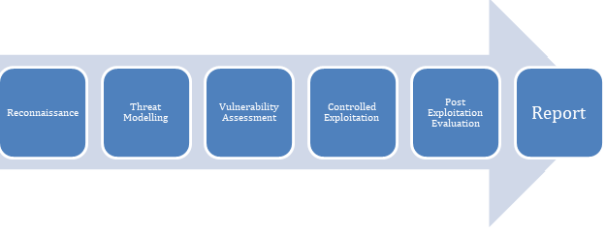

Audit Conducted
Below are the details of the Database Server for which the VAPT exercise was conducted.
Sr. No. | IP Address | Make | Model
1
2
3

Tools/ Software used
Sr. No. | Name of Tool / Software used | Version of the tool/Software used | Open Source / Licensed
1 | Burp Suite | Professional 2024.5.1 | Licensed
2 | Nessus Professional | 10.8.4 (#28) WINDOWS | Licensed
3 | Nikto | 2.5 | Open Source
4 | Nmap | 7.92 | Open Source
5 | GitHub Repository | Git | Open Source

Risk Summary
The vulnerability assessment and penetration testing exercise aims to highlight the existing vulnerabilities within the network Database Server and the different ways in which it can be addressed and closed.
We strongly recommend expeditious removal of the inconsistencies brought out in this report. Risks have been defined as critical, high, medium and low.
Critical risks: These risks have to be addressed on priority. The system is extremely vulnerable and needs prompt mitigation.
High risk: There is a strong need for corrective measures. The existing system may continue to operate but the corrective action needs to be implemented as soon as possible
Medium risk: Corrective actions are needed and a plan must be developed to incorporate these actions within a reasonable period of time.
Low risk: KServe BPO Pvt Ltd. shall determine whether corrective actions are still required or decide to accept the risk.
Likelihood
Level | Definition
High | The threat's source is highly motivated and sufficiently capable, and controls that prevent the vulnerability from being exercised are ineffective.
Medium | The threat's source is motivated and capable, but controls are in place that may impede a successful exercise of the vulnerability.
Low | The threat's source lacks motivation or capability, and controls are in place to prevent or significantly impede the vulnerability from being exercised.

Impact and Degree
Level | Definition
High | High impact risks may result in the high costly loss of assets; risks that significantly violate, harm, or impede operations; or risks that cause human death or serious injury.
Medium | Medium impact risks may result in the costly loss of assets; risks that violate, harm, or impede operations; or risks that cause human injury.
Low | Low impact risks may result in the loss of some assets or may noticeably affect operations.

Risk
Mitigation | Recommendation
Critical | This is a critical vulnerability and needs to be addressed immediately
High | There is a strong need for corrective measures. The existing system may continue to operate but the corrective action needs to be put in place as early as possible
Medium | Corrective actions are needed and a plan must be developed to incorporate these actions within a reasonable period of time
Low | Company to determine corrective actions or decide to accept the risk

Management Summary
Our Information Security Assessment team would like to take this opportunity to thank all the participants for their assistance and co-operation in ensuring that the assessment could be completed smoothly and in a timely manner.
5 Database Server were in the scope of the VAPT activity. Critical, Medium and low vulnerabilities were identified during the scan. The scan was done using multiple tools followed by manual verification to reduce the risks of false positives. It is recommended that the Critical, Medium and low vulnerabilities be addressed immediately.
It is further recommended that the Database Server be scanned for vulnerabilities whenever there is a change in the configuration or at least once in a year, whichever is earlier. All changes to the Database Server should be done through a proper change management process.
Below is the summarized report of the vulnerabilities.
Critical | High | Medium | Low | Information
2 | 3 | 4 | 1 | 0

Figure 1: Vulnerability Distribution with severity

S. No | Affected Asset | Observation/ Vulnerability title | CVE/CWE | Control Objective | Control Name | Audit Requirement | Severity | Recommendation | Reference | New or Repeat observation
1 | https://ginandjuice.shop/catalog | SQL Injection Vulnerability in Search Parameter | CWE-89: Improper Neutralization of Special Elements used in an SQL Command | NA | NA | NA | Critical | 1. Implement parameterized queries / prepared statements for all database interactions.  2. Apply strict server-side input validation and sanitization.  3. Use ORM frameworks wherever possible to avoid dynamic SQL queries.  4. Disable detailed database error messages in production environments.  5. Apply Web Application Firewall (WAF) rules to detect and block SQL Injection attempts.  6. Conduct secure code review and periodic penetration testing | 1. OWASP SQL Injection Guide  2. CWE-89 Reference | New Observation
2 | https://ginandjuice.shop/catalog | SQL Injection – Boolean-Based Blind SQL Injection | CWE-89: Improper Neutralization of Special Elements used in an SQL Command | NA | NA | NA | Critical | . Use parameterized queries / prepared statements.  2. Implement strict allow-list validation for input parameters.  3. Avoid dynamic SQL query construction.  4. Use ORM frameworks to securely handle database interactions.  5. Suppress database-related error handling from end users.  6. Deploy WAF protection against SQL Injection payloads | 1. OWASP Blind SQL Injection Guide  2. CWE-89 Reference | New Observation
3 | https://ginandjuice.shop/login | Multiple Active Session Vulnerability | CWE-613: Insufficient Session Expiration | NA | NA | NA | Medium | 1. Implement single-session enforcement for sensitive accounts.  2. Invalidate previous active sessions upon new login if business logic requires single active session.  3. Provide users with active session management functionality.  4. Implement session timeout and automatic logout mechanisms.  5. Notify users about new device/browser logins.  6. Regenerate session identifiers after successful authentication | OWASP Session Management Cheat Sheet  2. CWE-613 Reference | New Observation
4 | https://ginandjuice.shop/catalog | Credentials transmitted to server in plain text | CWE-319: Cleartext Transmission of Sensitive Information | NA | NA | NA | High | 1.Implement HTTPS/TLS for all authentication endpoints.  2.Disable insecure protocols (HTTP, FTP, Telnet).  3.Enforce strong encryption standards (TLS 1.2/1.3).  4.Conduct regular penetration testing to validate secure transmission | 1. OWASP Top 10: A2 – Broken Authentication  2.NIST SP 800-52 Rev.2: Guidelines for TLS  3.CWE-319 documentation | New Observation
5 | https://ginandjuice.shop/login | Default credentials have been used for authentication | CWE-798: Use of Hard-coded Credentials  CWE-259: Use of Hard-coded Password | NA | NA | NA | High | 1.Immediately change all default credentials to strong, unique passwords.  2.Enforce password complexity and rotation policies.  3.Disable or remove unnecessary accounts.  4.Implement multi-factor authentication (MFA) where possible | 1.OWASP Top 10: A2 – Broken Authentication  2.NIST SP 800-63B: Digital Identity Guidelines  3.CWE-798 documentation | New Observation
6 | https://ginandjuice.shop/resources/js/angular_1-7-7.js | Version disclosure of JavaScript library (AngularJS v1.7.7) | 1.CWE-200: Information Exposure  2.CWE-937: OWASP Top Ten 2017 Category A9 – Using Components with Known Vulnerabilities | NA | NA | NA | High | 1.Update AngularJS to the latest supported version or migrate to a modern framework.  2.Remove or obfuscate version information from public files and headers.  3.Implement a patch management process to ensure timely updates of third-party libraries. | 1.OWASP Top 10: A9 – Using Components with Known Vulnerabilities  2.NIST SP 800-53: SI-2 Flaw Remediation  3.CWE-200 documentation | New Observation
7 | https://ginandjuice.shop | Missing Content Security Policy (CSP) header | .CWE-693: Protection Mechanism Failure  2.CWE-942: Overly Permissive Content Security Policy | NA | NA | NA | Medium | 1.Implement a strict Content Security Policy header in all HTTP responses.  2.Restrict script sources to trusted domains.  3.Disallow inline scripts (unsafe-inline) and eval-like functions (unsafe-eval).  4.Regularly review and update CSP rules as the application evolves. | .OWASP Top 10: A9 – Using Components with Known Vulnerabilities  2.NIST SP 800-53: SI-2 Flaw Remediation  3.CWE-200 documentation | New Observation
8 | https://ginandjuice.shop | Missing Referrer-Policy HTTP response header | 1.CWE-693: Protection Mechanism Failure  2.CWE-942: Overly Permissive Content Security Policy | NA | NA | NA | Medium | 1.Implement a strict Content Security Policy header in all HTTP responses.  2.Restrict script sources to trusted domains.  3.Disallow inline scripts (unsafe-inline) and eval-like functions (unsafe-eval).  4.Regularly review and update CSP rules as the application evolves | 1.OWASP Secure Headers Project  2.Mozilla Developer Network (MDN) – Referrer Policy Documentation | New Observation
9 | https://ginandjuice.shop | Missing Referrer-Policy HTTP response header | 1.CWE-200: Information Exposure  2. CWE-693: Protection Mechanism Failure | NA | NA | NA | Medium | Review application URLs to ensure no sensitive data is embedded in query strings.  Regularly test header presence and configuration using automated scanners. | 1.OWASP Secure Headers Project  2.Mozilla Developer Network (MDN) – Referrer Policy Documentation  3.NIST SP 800-53: SC-7 Boundary Protection | New Observation
10 | https://ginandjuice.shop/catalog | Improper or missing input validation on user-supplied data | 1.CWE-20: Improper Input Validation  2.CWE-116: Improper Encoding or Escaping of Output | NA | NA | NA | Medium | 1.Implement strict input validation rules for all fields (e.g., RFC-compliant email validation).  2. Apply server-side validation as the primary control; client-side validation should be supplementary | 1.OWASP Cheat Sheet: Input Validation  2.OWASP Top 10: A03 – Injection  3.NIST SP 800-53: SI-10 Input Validation | New Observation
11 | https://ginandjuice.shop/resources/js/xmlStockCheckPayload.js | XML version disclosure | CWE‑200: Information Exposure  CWE‑201: Information Exposure Through Sent Data | NA | NA | NA | Low | Remove or obfuscate XML version declarations in client‑side code unless strictly required.  Ensure server‑side XML parsers are hardened against XXE and injection attacks.  Implement secure coding practices to avoid exposing unnecessary technical details. | OWASP XML Security Cheat Sheet  CWE‑611: Improper Restriction of XML External Entity Reference  NIST SP 800‑53: SI‑10 Input Validation | New Observation

Port Scan Details
Table shows the list of Open Ports/Services identified on the given resource / devices after scanning the Network.
Sr. No | IP Address | Port | Type | State | Service
1
2
3

Vulnerability Details
Vulnerability Severity Level:
Critical | 2
High | 3
Medium | 4
Low | 1
Information | 0

Detailed Report

- SQL Injection Vulnerability in Search Parameter

Affected Asset i.e. IP / URL / Application etc. | https://ginandjuice.shop/catalog
Observation/ Vulnerability title | SQL Injection Vulnerability in Search Parameter
Detailed observation / Vulnerable point | During security testing, it was observed that the Orderbyparameter in the product search functionality is vulnerable to SQL Injection. The application appears to process unsanitized user input directly into backend SQL queries. Testing with specially crafted payloads resulted in abnormal application behavior and database query manipulation, indicating insufficient input validation and lack of parameterized query handling
CVE/CWE | CWE-89: Improper Neutralization of Special Elements used in an SQL Command (‘SQL Injection’)
Control Objective | Not Applicable
Control Name | Not Applicable
Audit Requirement | Not Applicable
Severity | Critical
Recommendation | 1. Implement parameterized queries / prepared statements for all database interactions.  2. Apply strict server-side input validation and sanitization.  3. Use ORM frameworks wherever possible to avoid dynamic SQL queries.  4. Disable detailed database error messages in production environments.  5. Apply Web Application Firewall (WAF) rules to detect and block SQL Injection attempts.  6. Conduct secure code review and periodic penetration testing
Reference | 1. OWASP SQL Injection Guide  2. CWE-89 Reference
New or Repeat observation | New Observation
References to evidences / Proof of Concept | 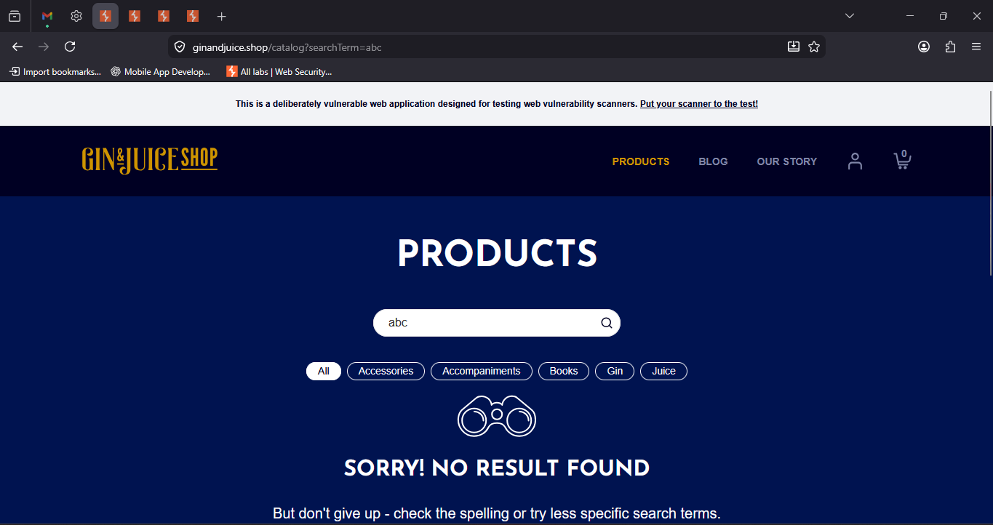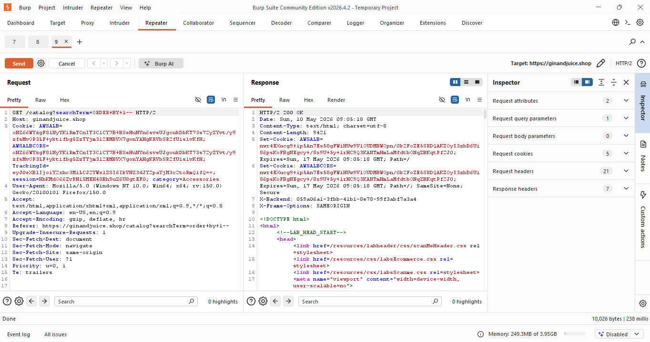

- SQL Injection – Boolean-Based Blind SQL Injection

Affected Asset i.e. IP / URL / Application etc. | https://ginandjuice.shop/catalog
Observation/ Vulnerability title | SQL Injection – Boolean-Based Blind SQL Injection
Detailed observation / Vulnerable point | During manual security assessment, the category parameter in the product filtering functionality was found vulnerable to Boolean-Based Blind SQL Injection. The application behavior changed based on injected TRUE/FALSE SQL conditions.  When a TRUE condition payload was supplied, the application returned valid product results. When a FALSE condition was tested, the application behavior changed and different/no results were displayed. This confirms that backend SQL queries are being influenced by unsanitized user input.
CVE/CWE | CWE-89: Improper Neutralization of Special Elements used in an SQL Command
Control Objective | Not Applicable
Control Name | Not Applicable
Audit Requirement | Not Applicable
Severity | Critical
Recommendation | 1. Use parameterized queries / prepared statements.  2. Implement strict allow-list validation for input parameters.  3. Avoid dynamic SQL query construction.  4. Use ORM frameworks to securely handle database interactions.  5. Suppress database-related error handling from end users.  6. Deploy WAF protection against SQL Injection payloads.
Reference | 1. OWASP Blind SQL Injection Guide  2. CWE-89 Reference
New or Repeat observation | New Observation
References to evidences / Proof of Concept | 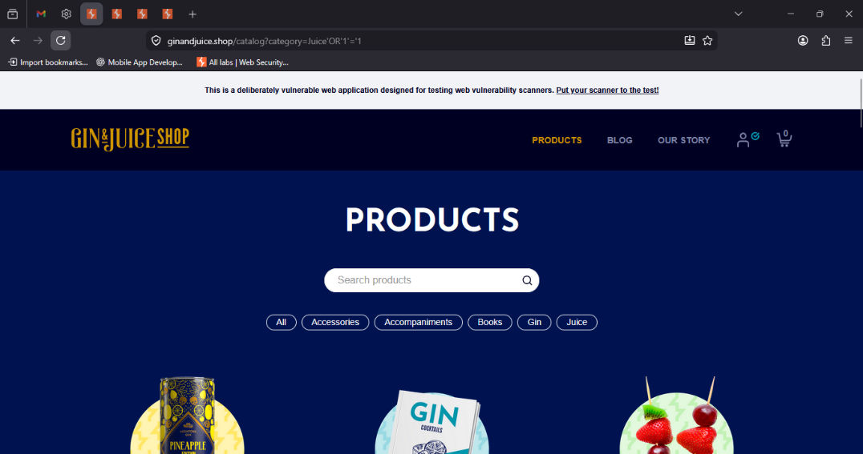

- Multiple Active Session Vulnerability

Affected Asset i.e. IP / URL / Application etc. | https://ginandjuice.shop/login
Observation/ Vulnerability title | Multiple Active Session Vulnerability
Detailed observation / Vulnerable point | During security assessment, it was observed that the application allows multiple simultaneous active sessions for the same user account across different browsers/sessions without session invalidation or user notification.  The same account remained authenticated concurrently in multiple browser instances, indicating absence of proper session management and concurrent session control mechanisms.  This weakness may allow unauthorized persistent access if session tokens are stolen or reused by attackers.
CVE/CWE | CWE-613: Insufficient Session Expiration
Control Objective | Not Applicable
Control Name | Not Applicable
Audit Requirement | Not Applicable
Severity | Medium
Recommendation | 1. Implement single-session enforcement for sensitive accounts.  2. Invalidate previous active sessions upon new login if business logic requires single active session.  3. Provide users with active session management functionality.  4. Implement session timeout and automatic logout mechanisms.  5. Notify users about new device/browser logins.  6. Regenerate session identifiers after successful authentication
Reference | 1. OWASP Session Management Cheat Sheet  2. CWE-613 Reference
New or Repeat observation | New Observation
References to evidences / Proof of Concept | 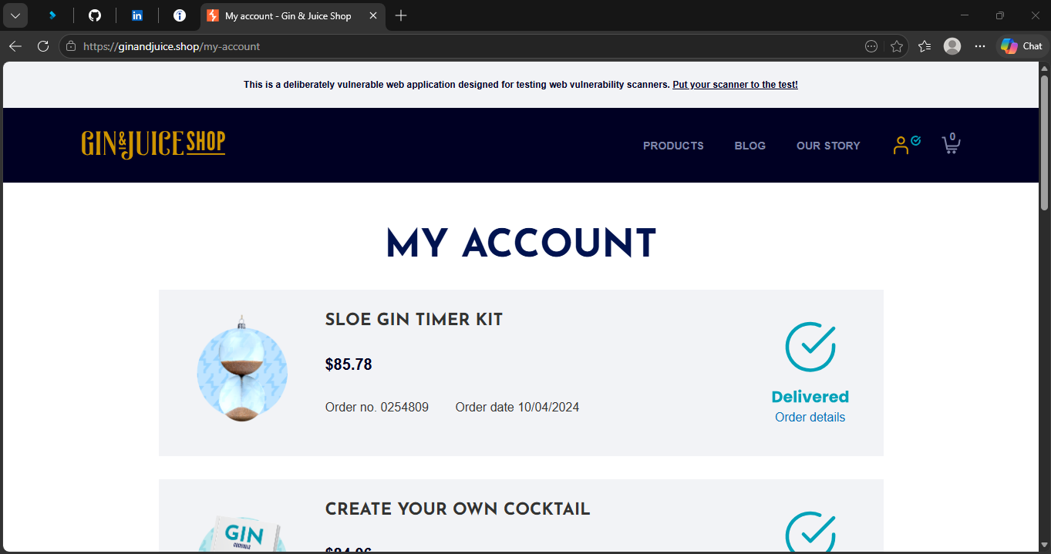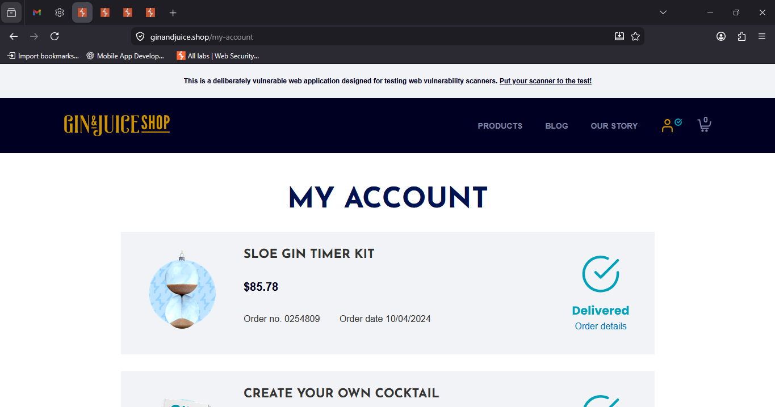

- Credentials transmitted to server in plain text

Affected Asset i.e. IP / URL / Application etc. | https://ginandjuice.shop/catalog
Observation/ Vulnerability title | Credentials transmitted to server in plain text
Detailed observation / Vulnerable point | During testing, it was observed that user credentials (username/password) are being transmitted over the network without encryption (HTTP/plain text).  This exposes sensitive authentication data to interception via packet sniffing, man-in-the-middle attacks, or unauthorized monitoring.
CVE/CWE | CWE-319: Cleartext Transmission of Sensitive Information
Control Objective | Not Applicable
Control Name | Not Applicable
Audit Requirement | Not Applicable
Severity | High
Recommendation | 1.Implement HTTPS/TLS for all authentication endpoints.  2.Disable insecure protocols (HTTP, FTP, Telnet).  3.Enforce strong encryption standards (TLS 1.2/1.3).  4.Conduct regular penetration testing to validate secure transmission.
Reference | 1. OWASP Top 10: A2 – Broken Authentication  2.NIST SP 800-52 Rev.2: Guidelines for TLS  3.CWE-319 documentation
New or Repeat observation | New Observation
References to evidences / Proof of Concept | 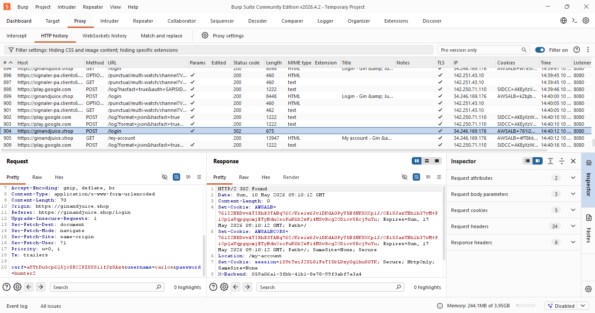

- Default credentials have been used for authentication

Affected Asset i.e. IP / URL / Application etc. | https://ginandjuice.shop/login
Observation/ Vulnerability title | Default credentials have been used for authentication
Detailed observation / Vulnerable point | During testing, it was observed that the application accepts default credentials (e.g., Username: carlos, Password: hunter2).  Default or hardcoded credentials are widely known and often published in vendor documentation, making them easy targets for attackers.  This significantly reduces the security posture of the application and increases the risk of unauthorized access.
CVE/CWE | CWE-798: Use of Hard-coded Credentials  CWE-259: Use of Hard-coded Password
Control Objective | Not Applicable
Control Name | Not Applicable
Audit Requirement | Not Applicable
Severity | High
Recommendation | 1.Immediately change all default credentials to strong, unique passwords.  2.Enforce password complexity and rotation policies.  3.Disable or remove unnecessary accounts.  4.Implement multi-factor authentication (MFA) where possible.
Reference | 1.OWASP Top 10: A2 – Broken Authentication  2.NIST SP 800-63B: Digital Identity Guidelines  3.CWE-798 documentation
New or Repeat observation | New Observation
References to evidences / Proof of Concept | 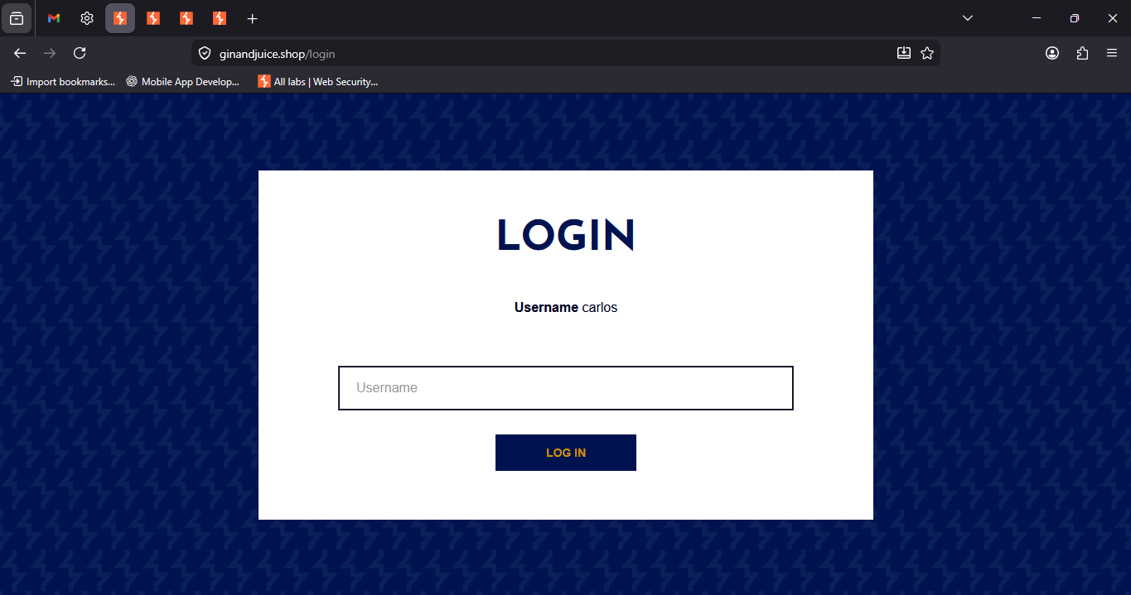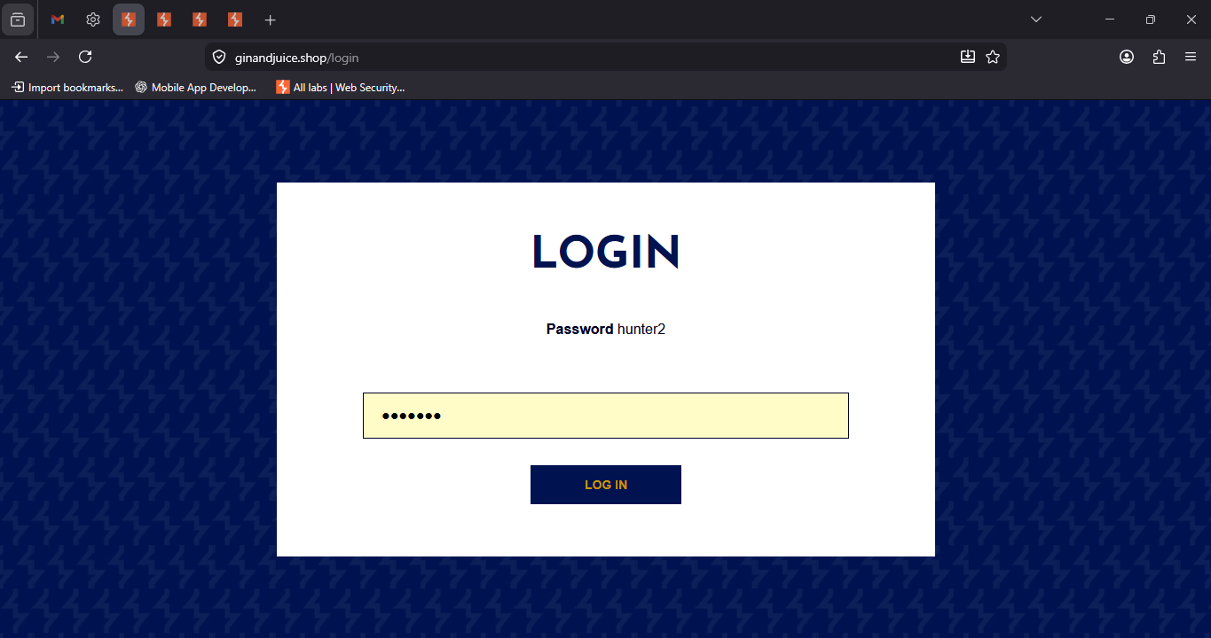

- Version disclosure of JavaScript library (AngularJS v1.7.7)

Affected Asset i.e. IP / URL / Application etc. | https://ginandjuice.shop/resources/js/angular_1-7-7.js
Observation/ Vulnerability title | Version disclosure of JavaScript library (AngularJS v1.7.7)
Detailed observation / Vulnerable point | 1.The application publicly exposes the exact version of AngularJS (1.7.7) in its JavaScript source file.  2.Disclosing framework versions allows attackers to identify known vulnerabilities associated with that version and craft targeted exploits.
CVE/CWE | 1.CWE-200: Information Exposure  2.CWE-937: OWASP Top Ten 2017 Category A9 – Using Components with Known Vulnerabilities
Control Objective | Not Applicable
Control Name | Not Applicable
Audit Requirement | Not Applicable
Severity | High
Recommendation | 1.Update AngularJS to the latest supported version or migrate to a modern framework.  2.Remove or obfuscate version information from public files and headers.  3.Implement a patch management process to ensure timely updates of third-party libraries.
Reference | 1.OWASP Top 10: A9 – Using Components with Known Vulnerabilities  2.NIST SP 800-53: SI-2 Flaw Remediation  3.CWE-200 documentation
New or Repeat observation | New Observation
References to evidences / Proof of Concept | 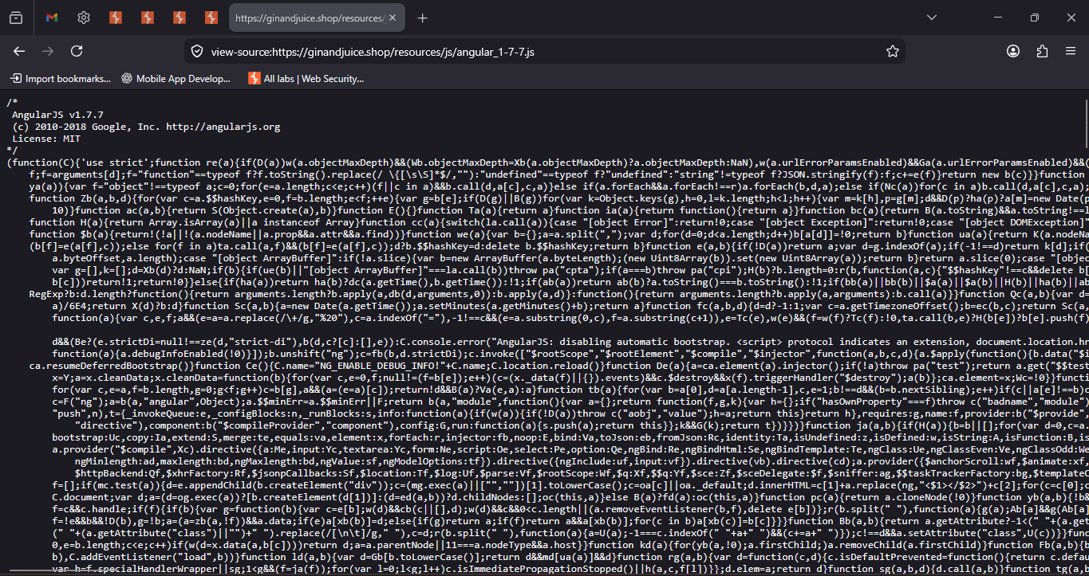

- Missing Content Security Policy (CSP) header

Affected Asset i.e. IP / URL / Application etc. | https://ginandjuice.shop
Observation/ Vulnerability title | Missing Content Security Policy (CSP) header
Detailed observation / Vulnerable point | 1.The application does not implement a Content Security Policy (CSP) header in its HTTP response.  2.Without CSP, the application is more susceptible to client-side attacks such as Cross-Site Scripting (XSS), clickjacking, and data injection.  3.CSP is a critical defense-in-depth mechanism that restricts sources of scripts, styles, and other resources.
CVE/CWE | 1.CWE-693: Protection Mechanism Failure  2.CWE-942: Overly Permissive Content Security Policy
Control Objective | Not Applicable
Control Name | Not Applicable
Audit Requirement | Not Applicable
Severity | Medium
Recommendation | 1.Implement a strict Content Security Policy header in all HTTP responses.  2.Restrict script sources to trusted domains.  3.Disallow inline scripts (unsafe-inline) and eval-like functions (unsafe-eval).  4.Regularly review and update CSP rules as the application evolves.
Reference | 1.OWASP Secure Headers Project  2.NIST SP 800-53: SC-44 – Detected and Prevented Code Execution
New or Repeat observation | New Observation
References to evidences / Proof of Concept | 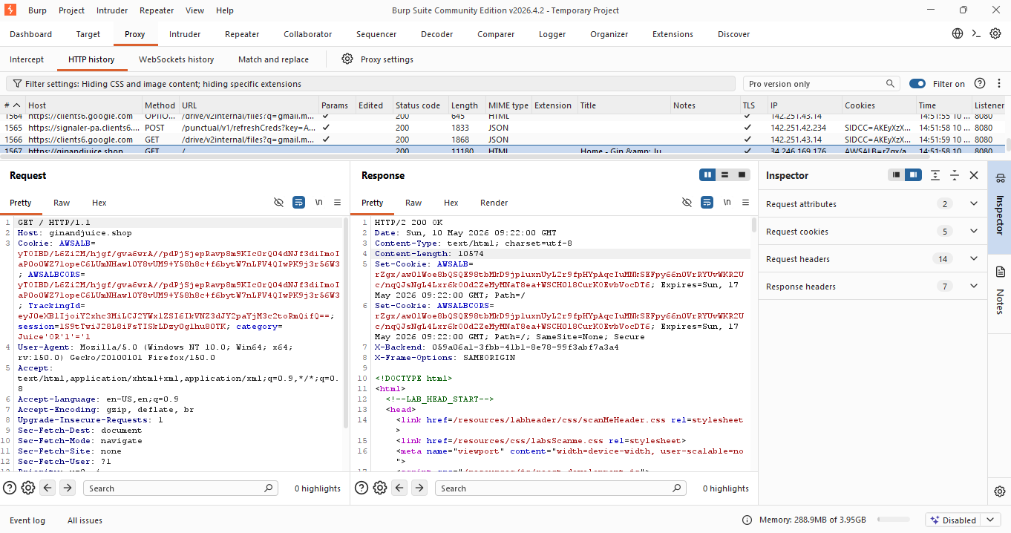

- Missing Referrer-Policy HTTP response header

Affected Asset i.e. IP / URL / Application etc. | https://ginandjuice.shop
Observation/ Vulnerability title | Missing Referrer-Policy HTTP response header
Detailed observation / Vulnerable point | 1 The application does not include a Referrer‑Policy header in its HTTP responses.  2 Without this header, browsers may send full URL referrer information—including query parameters—to external sites when users navigate away.  3 This can lead to unintended leakage of sensitive data such as session tokens, internal paths, or user identifiers..
CVE/CWE | 1.CWE-200: Information Exposure  2. CWE-693: Protection Mechanism Failure
Control Objective | Not Applicable
Control Name | Not Applicable
Audit Requirement | Not Applicable
Severity | Medium
Recommendation | Review application URLs to ensure no sensitive data is embedded in query strings.  Regularly test header presence and configuration using automated scanners.
Reference | 1.OWASP Secure Headers Project  2.Mozilla Developer Network (MDN) – Referrer Policy Documentation  3.NIST SP 800-53: SC-7 Boundary Protection
New or Repeat observation | New Observation
References to evidences / Proof of Concept | 

- Missing Referrer-Policy HTTP response header

Affected Asset i.e. IP / URL / Application etc. | https://ginandjuice.shop
Observation/ Vulnerability title | Missing Referrer-Policy HTTP response header
Detailed observation / Vulnerable point | 1 The application does not include a Referrer‑Policy header in its HTTP responses.  2 Without this header, browsers may send full URL referrer information—including query parameters—to external sites when users navigate away.  3 This can lead to unintended leakage of sensitive data such as session tokens, internal paths, or user identifiers.
CVE/CWE | 1.CWE-200: Information Exposure  2. CWE-693: Protection Mechanism Failure
Control Objective | Not Applicable
Control Name | Not Applicable
Audit Requirement | Not Applicable
Severity | Medium
Recommendation | Review application URLs to ensure no sensitive data is embedded in query strings.  Regularly test header presence and configuration using automated scanners.
Reference | 1.OWASP Secure Headers Project  2.Mozilla Developer Network (MDN) – Referrer Policy Documentation  3.NIST SP 800-53: SC-7 Boundary Protection
New or Repeat observation | New Observation
References to evidences / Proof of Concept | 

- Improper or missing input validation on user-supplied data

Affected Asset i.e. IP / URL / Application etc. | https://ginandjuice.shop/catalog
Observation/ Vulnerability title | Improper or missing input validation on user-supplied data
Detailed observation / Vulnerable point | 1.The application accepts invalid or malformed input (e.g., nonsensical email addresses such as asdsad@add.assded) without proper validation.  2.This indicates weak or absent client-side and server-side validation controls.  3.Such flaws can lead to issues including data integrity problems, spam registrations, injection attacks, or exploitation of business logic.
CVE/CWE | 1.CWE-20: Improper Input Validation  2.CWE-116: Improper Encoding or Escaping of Output
Control Objective | Not Applicable
Control Name | Not Applicable
Audit Requirement | Not Applicable
Severity | Medium
Recommendation | 1.Implement strict input validation rules for all fields (e.g., RFC-compliant email validation).  2. Apply server-side validation as the primary control; client-side validation should be supplementary.
Reference | 1.OWASP Cheat Sheet: Input Validation  2.OWASP Top 10: A03 – Injection  3.NIST SP 800-53: SI-10 Input Validation
New or Repeat observation | New Observation
References to evidences / Proof of Concept | 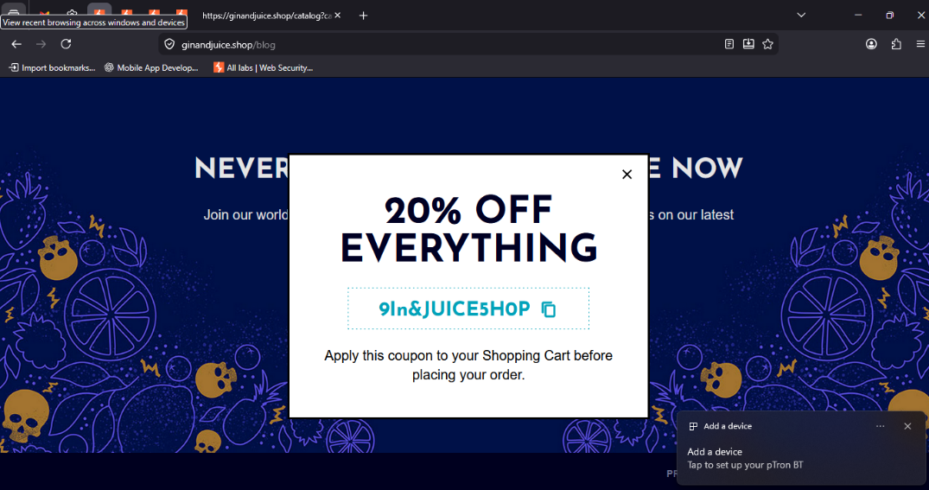

- XML version disclosure

Affected Asset i.e. IP / URL / Application etc. | https://ginandjuice.shop/resources/js/xmlStockCheckPayload.js
Observation/ Vulnerability title | XML version disclosure
Detailed observation / Vulnerable point | The application’s JavaScript code explicitly constructs XML payloads with a hardcoded version declaration (<?xml version="1.0" encoding="UTF-8">).  Exposing XML version and encoding details can provide attackers with unnecessary information about the system’s data handling and may assist in crafting malicious payloads (e.g., XML External Entity (XXE) attacks or malformed XML injection).  While not a direct exploit by itself, version disclosure increases the attack surface by revealing implementation details..
CVE/CWE | CWE‑200: Information Exposure  CWE‑201: Information Exposure Through Sent Data
Control Objective | Not Applicable
Control Name | Not Applicable
Audit Requirement | Not Applicable
Severity | Low
Recommendation | Remove or obfuscate XML version declarations in client‑side code unless strictly required.  Ensure server‑side XML parsers are hardened against XXE and injection attacks.  Implement secure coding practices to avoid exposing unnecessary technical details.
Reference | OWASP XML Security Cheat Sheet  CWE‑611: Improper Restriction of XML External Entity Reference  NIST SP 800‑53: SI‑10 Input Validation
New or Repeat observation | New Observation
References to evidences / Proof of Concept | 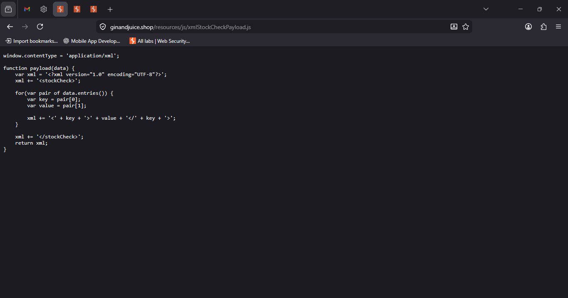

-------End of Report-------

